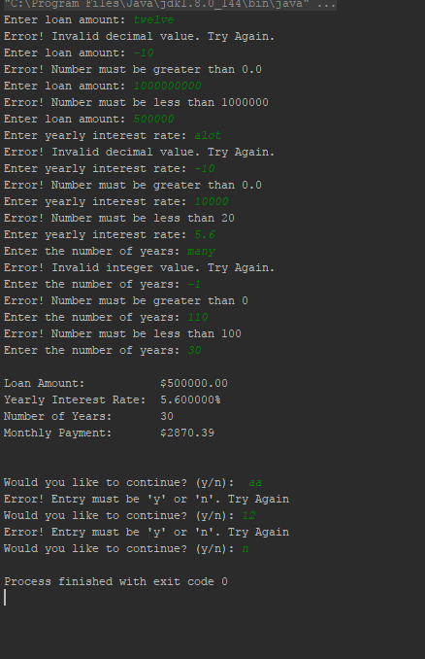

Invalid data entry is handled by each variable having it’s own method it’s passed through. The method will loop until a valid number or character is entered.

Referenced javadoc page: <https://docs.oracle.com/javase/8/docs/api/java/util/Scanner.html#hasNextDouble-->

<https://docs.oracle.com/javase/8/docs/api/java/util/Scanner.html#nextLine-->

<https://docs.oracle.com/javase/8/docs/api/java/util/Scanner.html#next-->